Introduction to Microsoft  Word | Literacy Services of Wisconsin  2011

Accessing Microsoft Word
- Click the Start button on the taskbar at the bottom left-hand corner of the screen.
- Click on Microsoft Word, which will launch the program.
- If Microsoft Word is not in the start menu, click on Office. A submenu should appear; when it does click on Microsoft Word.

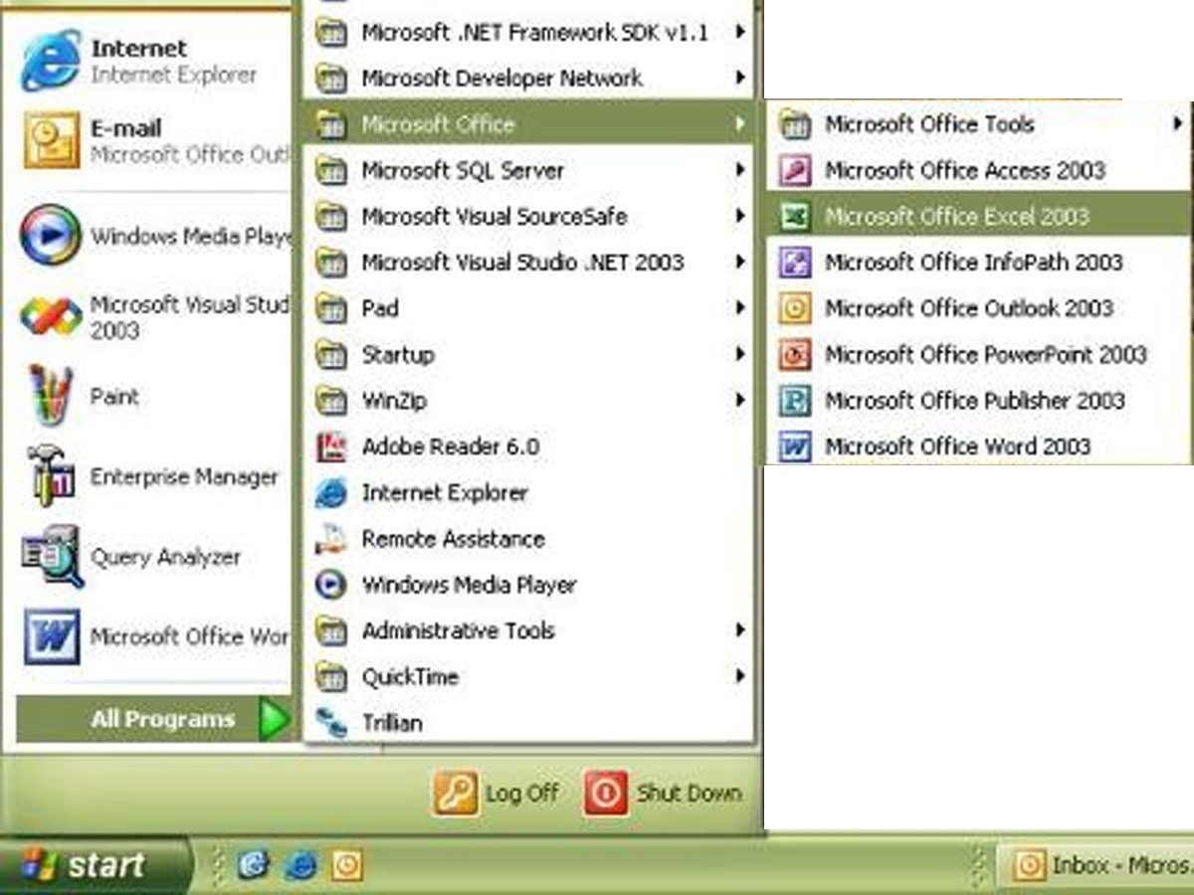

Microsoft Word Window
Maximize/Restore
Menu Bar (Drop down)
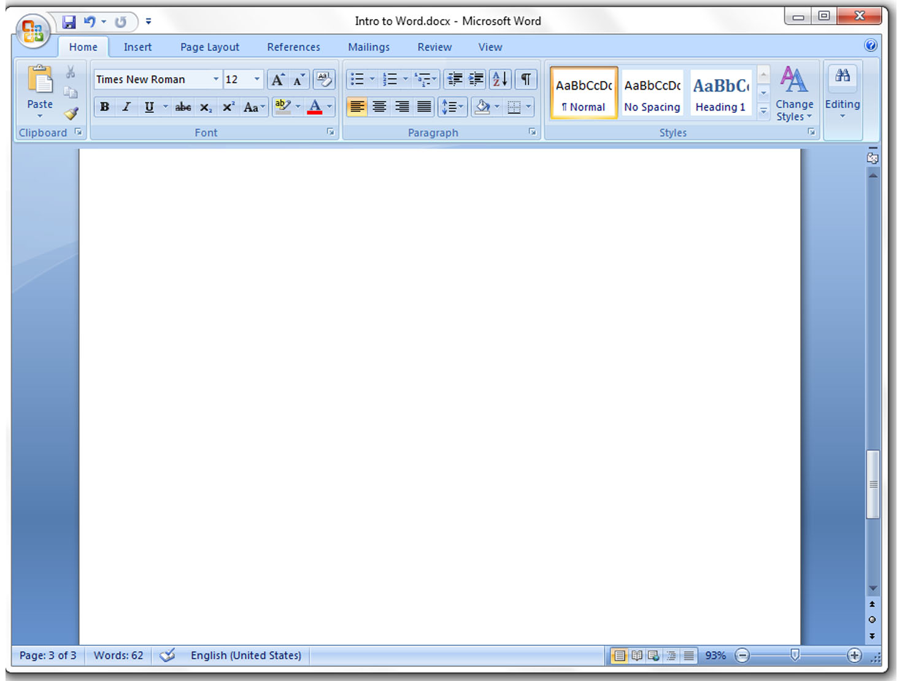
Zoom
Status Bar
Close/Exit
Minimize
Toolbar Tabs
Title Bar
Standard Toolbar
Microsoft Menus & Toolbars
Main Menu
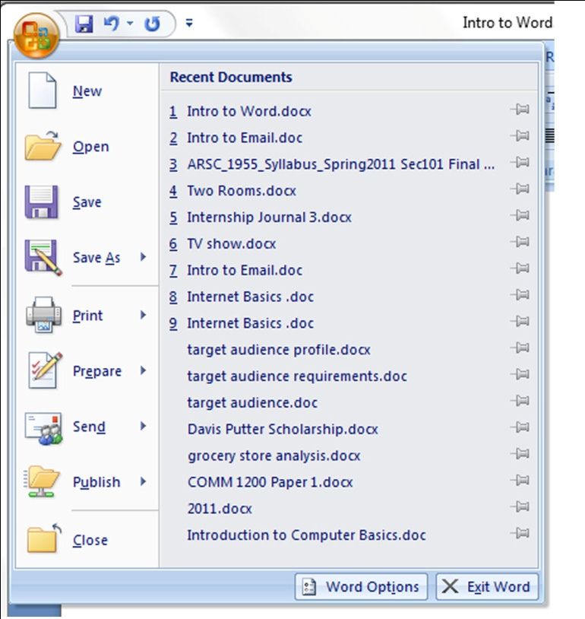
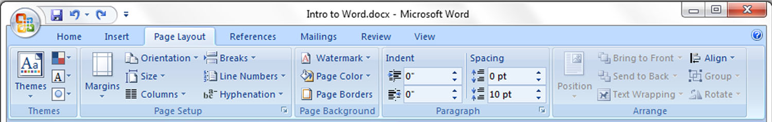
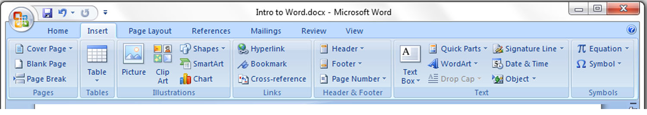
Save in a Different Format
Open a Saved Document
New Document
Post to a Blog (Web log)
Email or Fax Document
Privacy Settings
Print Document
Save Document
Layout Tools
Insert Tools
Menus & Toolbars Continued

References Help
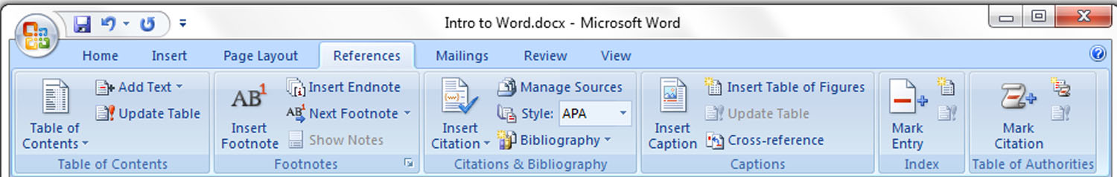

Mailing/Letter Formatting
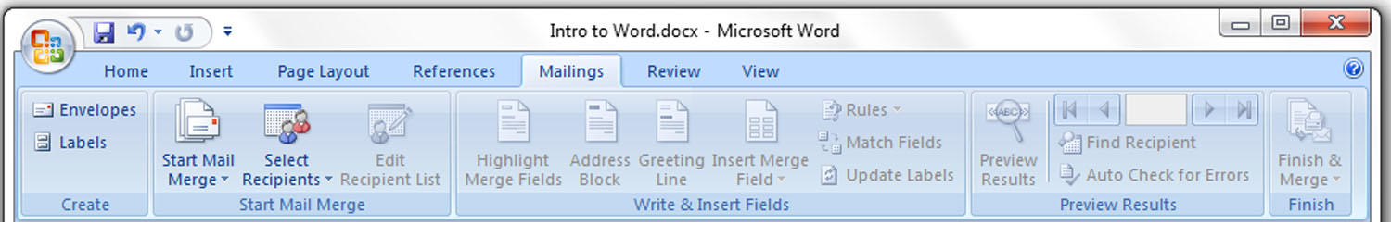

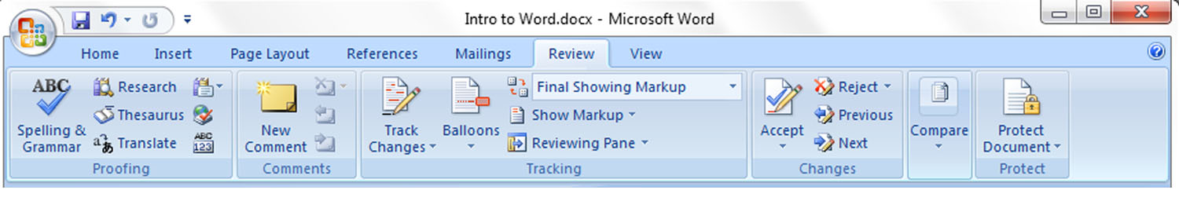
Spelling, Grammar, & Document Review

Viewing Options
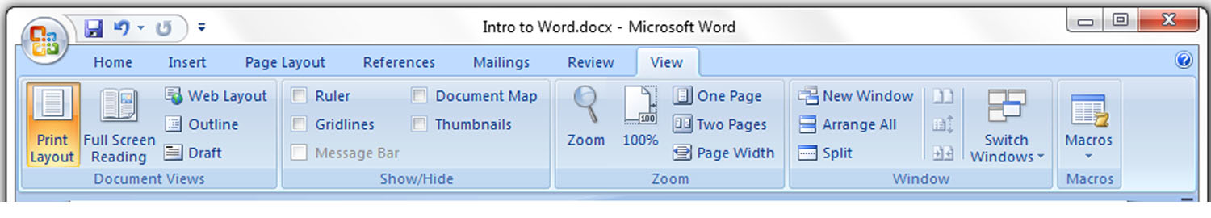

Standard Toolbar

Indenting
Bullet Points & Numbering
Font
Font Size
Extra Styles
Right, Center, Left, Justify
Font Style
Sort & Alphabetize
Line Spacing
Highlight Text
Font Color

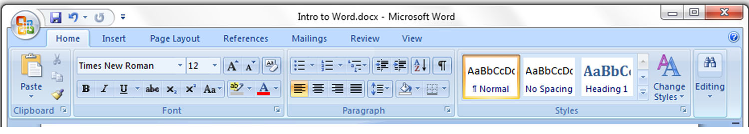

Align:

Cursors & Keys
Cursors:
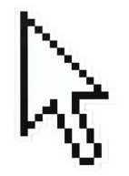
Flashing Cursor (Just pretend for now)
I-Beam
Arrow

Shows current place in text.
Default cursor.
Lets you select a spot within the text.

Keys:
Space Bar: Inserts one space between words
Enter Key: Creates a new paragraph and moves the cursor to the next line
- Text will automatically flow to the next line while you are typing in the Word program. You do not need to press the Enter key to get to the next line, unless you want to create a new paragraph
Tab Key: Automatically moves the cursor in one half-inch increments.
Shift Key: Capitalizes letters typed while this key is held down.
Caps Lock Key: When this key is pressed, a green light will display on the right hand side of the keyboard. All letters typed while this light is on will be capitalized. Press again to turn Caps Lock off.
Insert Key: When this key is pressed, it turns on Overtype mode. This mode allows users to type over text while editing a document.
Back Space Key: Deletes one character to the left.
Delete Key: Deletes one character to the right.
Insert
Delete
Back Space
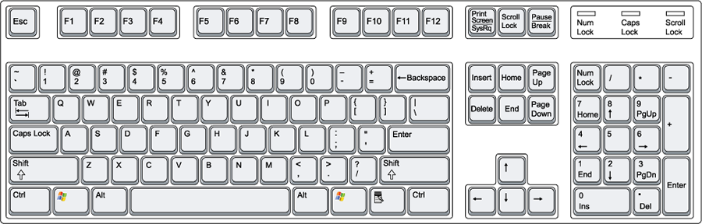
Tab Key

Caps Lock
Enter Key
Space Bar
Shift
Navigating and Selecting Text
In order to effectively use the Microsoft Word program it is important to know how to move around the document. You can use both the mouse and keyboard to navigate through a document.
Using the Mouse:
- Simply point and click on the desired location. The flashing cursor will appear at the selected spot.
Using the Keyboard:
Key | Action | Key | Action
← | one space left | Ctrl+← | one word to the left
→ | one space right | Ctrl+→ | one word to the right
↑ | one line up | Ctrl+Home | beginning of the document
↓ | one line down | Ctrl+End | top of next page
Home | beginning of the line | Ctrl+Page Up | top of previous page
End | end of the line | Ctrl+Page Down
Page Up | up a screen length
Page Down | down a screen length

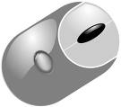
Make sure you are clicking with the left mouse button!

Navigating and Selecting, Cont.
You may wish to make a certain word bold, underline a phrase, or increase the size of the text for the entire document. Before any of these actions can be performed, you must select the text you wish to change. There are a number of ways you can select text, both with the mouse and with the keyboard.
Using the Mouse:
Action | Selects
click, hold, and drag | specified area  Instead of clicking, holding, and dragging, you can shift click!  - Click where you would like the selection to begin  - Hold the Shift Key.  - Click where you would like the selection to end.
double click a word | word
triple click a word | paragraph
single click | line
double click | paragraph
triple click | entire document

Using the Keyboard:
Keyboard | Selects | Keyboard | Selects
Ctrl+a | entire document | Shift+End | to end of line
Shift+← | one character to the left | Ctrl+Shift+Home | from cursor to beginning of document
Shift+→ | one character to the right | Ctrl+Shift+End | from cursor to end of document
Shift+↑ | one line up | Ctrl+Shift+↑ | from cursor to beginning of paragraph
Shift+↓ | one line down | Ctrl+Shift+↓ | from cursor to end of paragraph
Shift+Home | to beginning of line

*Side Note:
When using the mouse, you must click fast! Clicking two or three times slowly will not select anything.
Editing Text
After you have typed a paragraph or sentence, you may wish to add a word or phrase. To do this, click where you would like to add text and begin to type.
Practice Inserting Text:
- To begin, open a new document and type the following poem:
HOW MANY, HOW MUCH
How many slams in an old screen door?
Depends on how loud you shut it.
How many slices in a bread?
Depends how thin you cut it.
How much good inside a day?
Depends how good you live ‘em.
How much love inside a friend?
Depends how much you give ‘em.
- After the last line of the poem type “By: Silverstein.”
- Click after the : next to the word “By:”
- Press the Space Bar and type “Shel.”
You have just inserted the author’s first name between the word “by” and his last name! (By: Shel Silverstein)

You may wish to delete text within the document you’ve created. To do this, select the text you wish to discard and press the delete key on the keyboard. Or, place your cursor and use the appropriate key to remove text (the backspace key deletes one character to the left and the delete key deletes one character to the right).
Practice Deleting Text:
- Type =rand(8) and hit enter to insert eight paragraphs of generic text.
- Using one of the selection methods, pick a few words to delete.
- Hit the Delete key or the Backspace key. The words you have selected will be deleted.

Editing Text, Cont.
When preparing a draft of a document, you may realize that you would like to move a paragraph to a different spot in the document or move a sentence from one paragraph to another.

Practice Moving Text:
Paste Button
- Type to following three sentences:
- Literacy Services is great.
- I love to read.
- Books rock!
Cut Button
- Select the sentence Literacy Services is great.
- Click the Cut button on the Standard Toolbar.
Copy Button
- Click at the end of the first sentence (I love to read).
- Click the Paste button on the Standard Toolbar.
Your sentences should now read:
I love to read. Literacy Services is great. Books rock!
You can also rearrange text by selecting the text you want to move, then dragging the selection to the desired place in the document.

You may wish to copy text from one paragraph to another, or copy a paragraph from one document to another document.
Practice Copying Text:
- Select all three sentences (I love to read. Literacy Services is great. Books rock!).
- Click the Copy button on the Standard Toolbar.
- Click at the end of the sentence and press the Enter key twice to create a new paragraph.
- Click the Paste button on the Standard Toolbar. A copy of the sentences will be inserted in the space below.

Undo and Redo
Often times while you are working on a document you may delete text by accident, type something incorrectly, or accidentally move text. If you make such mistakes, they are very easy to correct.
Undo
The Undo command allows you to reverse the last action performed. If you made more than one mistake, you can keep licking the Undo button to undo multiple actions. The down pointing arrow next to the Undo button lists all the actions that you have recently performed.
Redo
The Redo command reverses the last action of the Undo command, so if you accidentally Undo an action you can fix it by clicking the Redo button.
Practice Using Undo and Redo:
- Select the entire document using one of the methods listed earlier in the tutorial.
- Press the Delete key. All of the text should be deleted.
- Click the Undo button. The text should reappear, because deleting it was your last action.
- Now click the Redo button.
- The text should disappear again, because the action you did earlier (deleting the text) has been redone.

Undo
Redo

List of Actions
Checking and Correcting Spelling Errors
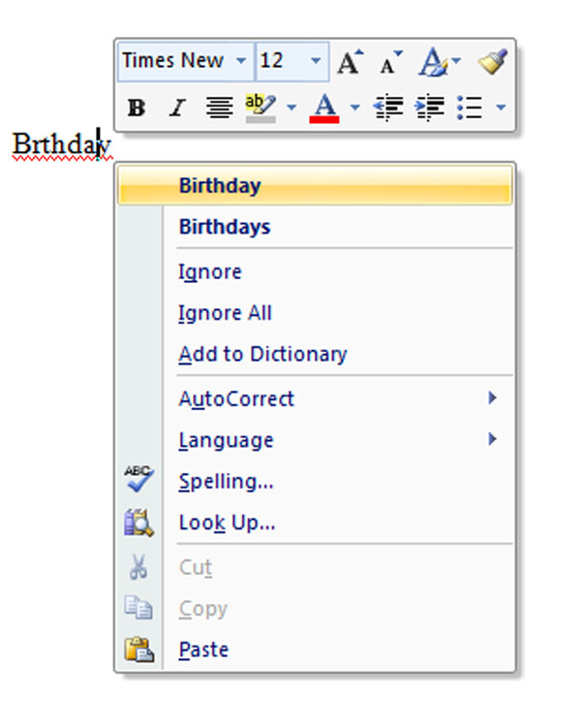
A spelling or typographical error can be costly especially on important documents such as cover letters, résumés, and reports. Microsoft Word has several different mechanisms in place to catch these errors and correct them.
Spell-it: A visual cue to errors within a document.
- The Spell-it feature places a wavy red line underneath words not recognized by the main dictionary and a green wavy line underneath shows possible grammatical or typographical mistakes.
- Right click the words with this underlining to open a shortcut menu with possible suggestions which you can either change or ignore. Right click for the short cut menu and left click to make your selection.
- Words that are in uppercase or words with numbers are ignored by this checking system.
  - e.g. LITERACY or literacy23
AutoCorrect: Automatically corrects common errors as you type
- Corrects commonly misspelled words (“teh” to “the”)
- Capitalizes the first letter in a sentence
- Capitalizes days of the week
- Corrects accidental use of the caps lock key (“tHE” to “The”)
- Corrects two initial capitals (“THe” to “The”)
- Inserts special symbols (e.g. copyright and trademark)
Spelling and Grammar Checker: Checks for misspellings and grammatical errors
- Click the Spelling and Grammar button on the Review toolbar to open.
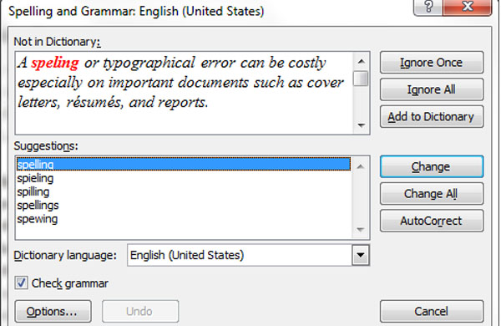
- This checking system will catch errors not detected by Spell-it and AutoCorrect. You can either change or ignore the suggestion. It is recommended to always perform the Spelling and Grammar checker before you print the document.
*Note: You should still read over the entire document in addition to using spell checker! It will not catch things like “The horse has a pretty man” when you meant “The horse has a pretty mane.”
Font Formatting
The default typeface, or font as it is commonly referred to, used for all Word documents is Calibri (which is the font you are seeing these words in) point size 11. If you have an older version of Word or if the settings have been changed, the default will be Times New Roman point size 12, which is the font this tutorial is in.
There may be times when you would like to change the appearance of your document by underlining certain phrases, making words bold, italicizing sentences, or changing the font or font size. You can make these changes from the Standard Toolbar, but it may be easier for you to change them from the Font Dialog Box.
Practice Changing Font Settings:
- Open a document within the Microsoft Word program.
- Select text within the document that you would like to change.
- Right click on the highlighted section. A menu will appear. Left Click on Font.
- The Font Dialog Box will now open.
- You can change the font type, style, and size. You also have the ability to select different underlining styles, the color of the text, and other interesting effects such as shadow, outline, or emboss.
  - Once you have made your changes, a preview displays at the bottom of the dialog box showing how the formatted text looks.
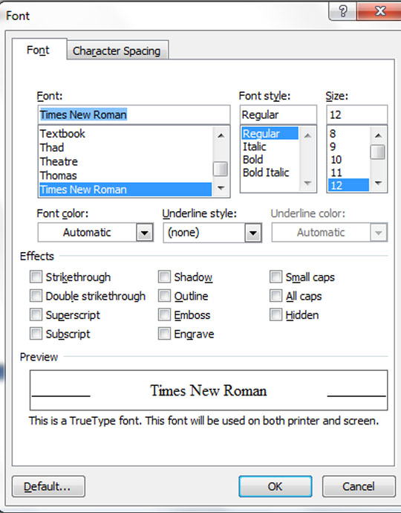
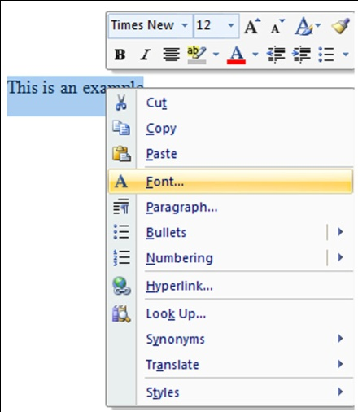
- Click the OK button to save your changes.

Notes About Fonts:
- 72-point size is equivalent to 1 inch.
- Font sizes 10, 11, or 12 are used in most professional documents.
- If you mark the “hidden” effect, the text will not print.

Paragraph Formatting
Changing the alignment of the text, the indentation of paragraphs, or the space between lines are options you can select to help make certain parts of your document stand out or make it more readable. Again, this is directly editable from the Standard Toolbar, but for more detailed options you will need to use the Paragraph Dialog Box.
Practice Formatting a Paragraph:
- Open a document within the Microsoft Word program.
- Select the area you wish to format.
- Right click on the highlighted area. The same menu from before will appear. Left click Paragraph.
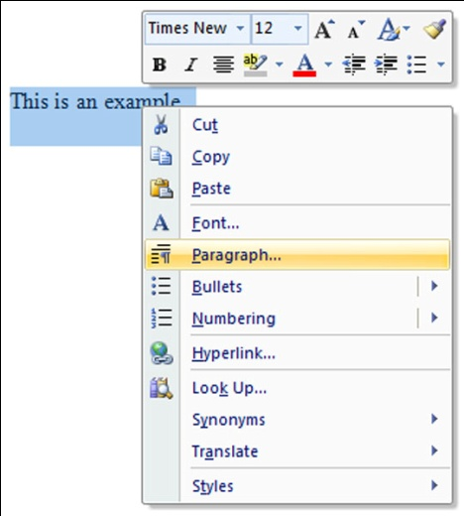
- The Paragraph Dialog Box will now open.
- You can change the line spacing (single, 1.5, double, etc.), you can adjust the alignment (left, center, right, or justify), or you can increase the spaces before or after paragraphs.
- Make your selections.
- A preview will display at the bottom of the dialog box once you have picked.
- Click the OK button to save your changes.
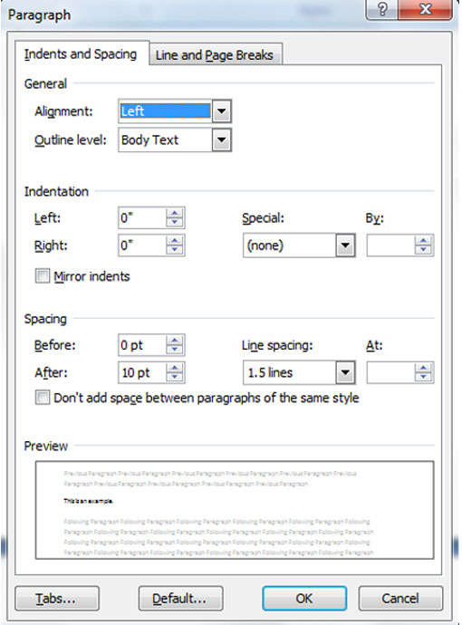

If you don’t know what something does, click the question mark in the upper left hand corner to access context sensitive help. An online window will open to help you with anything you’re having trouble with.

Accessing Print Preview
Before you print a document, you may wish to see how it will look when it’s printed. Print Preview has different magnifications for viewing the document. You can zoom in and out and make final adjustments before printing.
To access Print Preview:
- Click on the dropdown menu in the upper left-hand corner
- Hover over Print
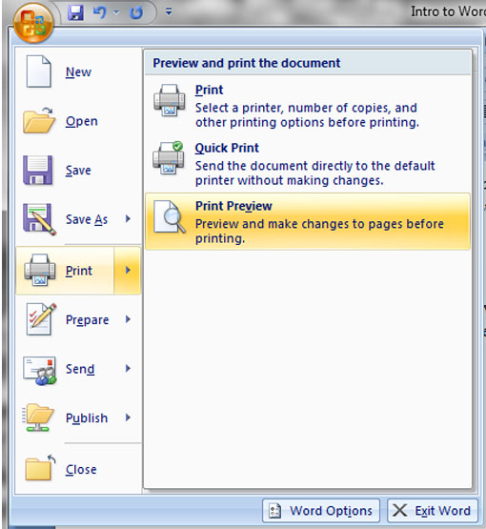
- Select Print Preview from the submenu.

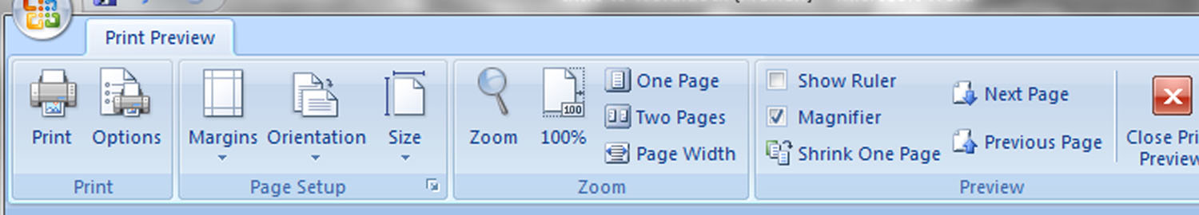

Zoom: magnify parts of the document
Pages: Select how many pages you want to see at one time
Shrink to Fit: decreases the font size to reduce the number of pages
Orientation: decide which way the content should appear on the paper; portrait or landscape
Print: Send the document to the printer

Adjusting the Page Layout
After you have edited and formatted a document, you may want to make other adjustments such as changing the margins, selecting a different paper size, or modifying the orientation. These actions can be performed in the Page Layout Toolbar.
Practice Adjusting Page Layout:
- Open a document in Microsoft Word.
- Click on the Page Layout Toolbar.
- By default, the top and bottom margins are set to 1 inch. The left and right margins are set at 1.25 inches. If you want to change this, you can either select a preset or select Custom, which will open the Page Setup Dialog Box.
- If you choose to open the Dialog Box, you can type the number for the margin setting you would like or use the arrows to increase or decrease the current setting. Orientation is also accessible from the Dialog Box.
- To adjust the orientation, there are two settings, portrait and landscape. Word documents print pages with a portrait orientation by default. You can change it to landscape by selecting Orientation and clicking Landscape.

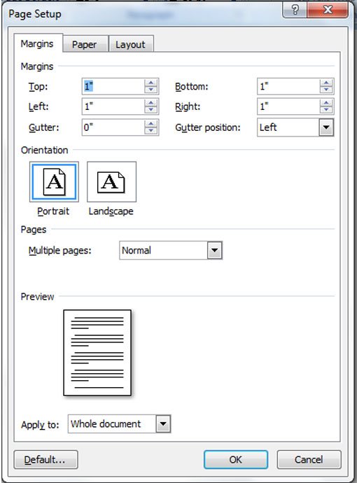
Margin Adjustment

Orientation

Printing, Saving, and Reopening
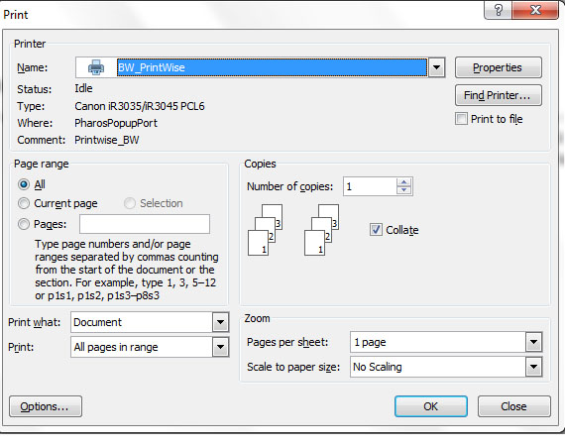
How to Print: Go to the dropdown menu in the upper left-hand corner and select print. A selection box will appear. If there is more than one printer available, you will need to select which one you would like the document sent to. Set the number of copies you want printed and hit Print.
**You cannot print to the Literacy Services printers!

Saving a Document:
- Click the Save button on the standard toolbar, located next to the Undo and Redo arrows, or go to the dropdown menu and hit Save.
- A “Save As” dialog box will open when you save a document for the first time.
- In the File Name box type a name for your file. Try to name it so that you will remember what the content is; for example, you might call this tutorial “Intro to Word.”
- Click on the arrow to the right of the Save In box.
- Select your flash drive. Please do not save documents to the Literacy Services computers!
- Your flash drive will probably be labeled as “Removable Hardware” or the name of the company who made the flash drive followed by a letter and colon, such as Lexar (E:)
- Click on the Save button.
- The document has been saved. The file name should appear on the title bar in the top of the window.
Reopening a Document
- Open Word.
- Go to the dropdown menu in the upper left-hand corner and select “Open.”
- Make sure you have selected the same location you saved to, select the document you want and either double click, hit enter, or press the Open button.

