Introduction to E-Mail | Literacy Services of Wisconsin  2011
 |  | 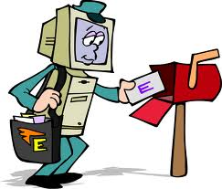

Course Description:
Email has become the most common form of online communication. It can be used to communicate with friends and family members as well as business and professional contacts. There are many web sites that allow users to sign up for free email accounts. These free email accounts are relatively easy to use and allow users to check their messages from any computer that has an Internet connection anywhere in the world. Email is extremely important for taking part in other forms of online communication such as chat rooms, bulletin boards, and listservs. Class will provide the basics for sending and receiving messages.

Class Length: 2 hours

Course Objectives: In order to successfully pass this course, students must execute/complete the following course objectives:

- Register for a free email account
- Articulate the importance of establishing an email account
- Compose, send, and reply to a message
- Sign in and out of their email account

Exercises

- Understanding Email Basics

- What is Email?
- The Email Address
- Other Forms of Online Communication

- Registering for an Email Account

- Register with a Free Email Provider
- Explore the Interface
- Open a Message

- Composing & Sending Messages

- Compose a Message
- Send a Message
- Reply to a Message

- Signing In & Out

- Sign Out
- Sign In
- Check Mail

The Email Address
Just as you would give someone your name, address, city, state, and zip code if you wanted a package sent to your home, you would need to provide an email address if you wanted to receive an electronic message.

Components of the Email Address

Email addresses have three main components. The first is the username which you can select. Many individuals opt for a first and middle initial followed by their last name or a combination thereof. Others prefer using nicknames or codenames for privacy or secrecy. The second component is the @ symbol. The third component is the host’s name. The host’s name is simply the name of the email provider or Internet Service Provider (ISP).

Username
The “at” symbol
Domain

myname@gmail.com

Host’s name (Free Email provider or Internet Service provider)
Host’s affiliation
Accessing Google Mail/Gmail
There are many places you can visit to sign up for a free email account. Many directories and search engines provide such services. The Internet changes on a daily basis and web sites are constantly being updated and redesigned. The following handouts walk you through the registration process for a Google Gmail account. Certain steps may change; however, the overall process will pretty much stay the same. If you are concerned about how the information you provide is used, read Google’s Privacy Policy.

Steps to Opening an Email Account:

1. Access Internet Explorer from the Start menu.
2. Click in the Address bar and type [www.Google.com], the address to the Google website.
3. Press the Enter key.
- The Google Web Site loads in the web browser.
- Click the blue Gmail link at the top left-hand side of the screen.
Another webpage will load.
5. Click the hyper link that says Create an account.

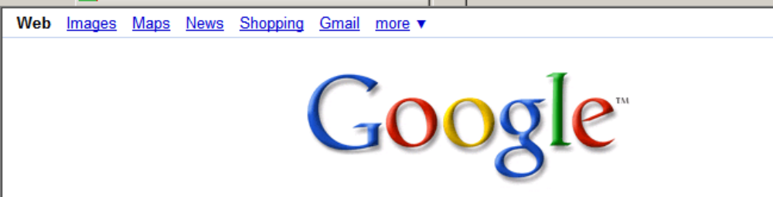

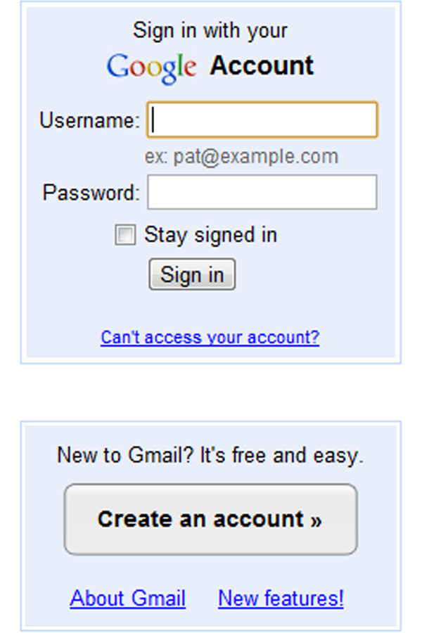

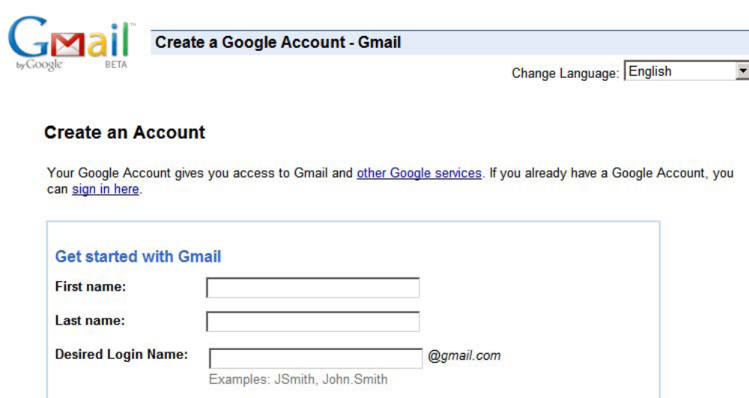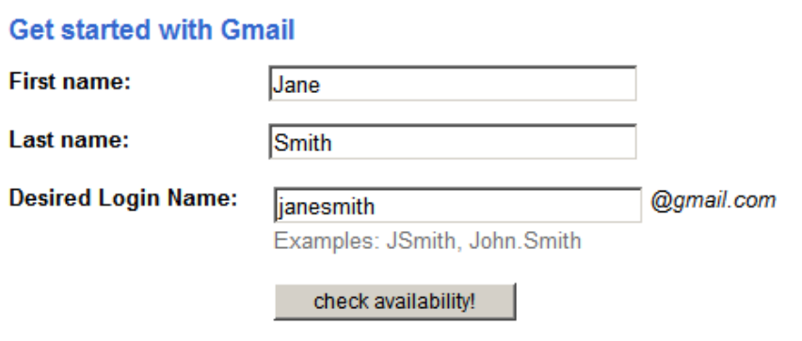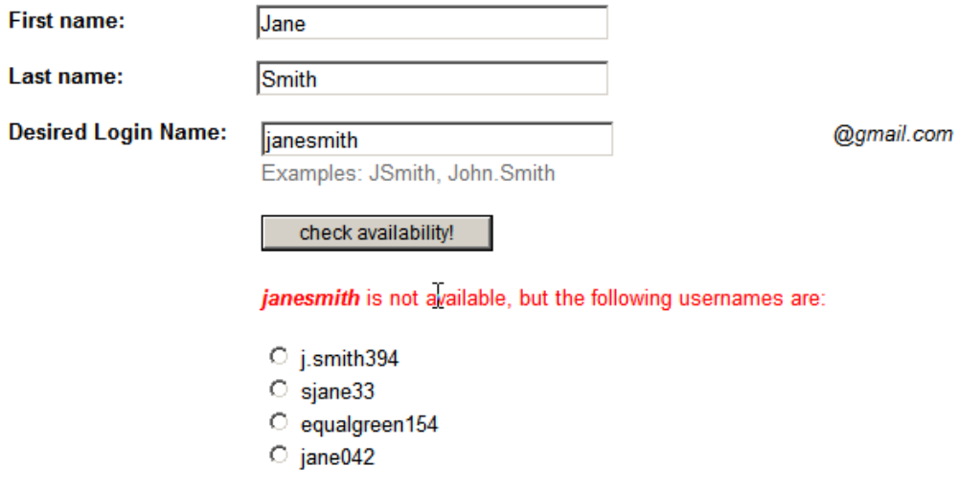
You cannot have the same ID as someone else, so you must check to see if the ID you want is available.
Tips for Gmail IDs:
- Include your first and last name (this will display when you send others messages-although you can always modify it later).
- Your Gmail ID can be a combination of letters and numbers; however, it must begin with a letter.
- Do not include spaces or other punctuation marks in your Gmail ID.
Next, you will need to make a password.
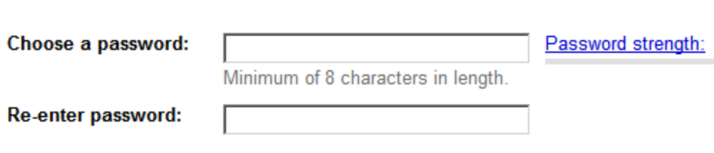
Tips for Gmail Passwords:
- Passwords are case sensitive, meaning capitalization matters
- Passwords can contain any character including letters, numbers, symbols, and spaces. You must have 8 or more characters in your password.
- Your password will show up as dots for security reasons.
- Your password must be unique and not similar to your ID, name, or security answer (see next step)

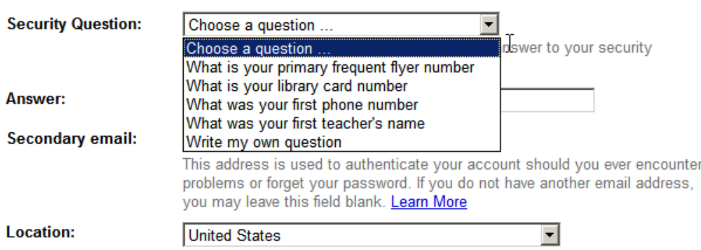

In case you forget your password…
- Choose from a list of security questions (e.g. What is your mother’s maiden name?)
- Remember how you enter the information! (e.g. 4th Street is not the same as Fourth St.)

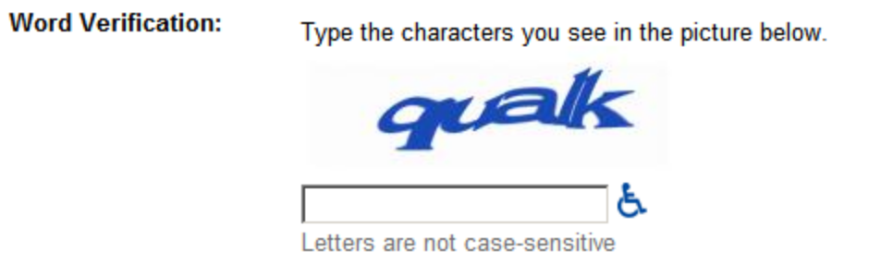
Word Verification: What is this?
- Typing the code in the box lets Google know you are a human and not an automated program.
- If you are not sure what the code says, take your best guess. If you guess incorrectly, you can try a different code on the next screen.
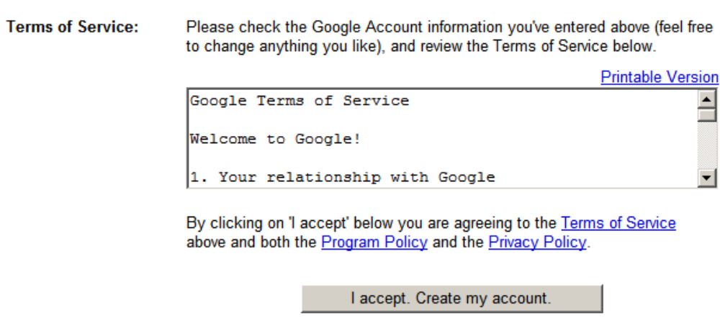
When you have finished answering all of the questions, agree to the Terms of Service by clicking the “I accept” button.

Write your information in the box below and keep it in your files in case you forget your information!

USERNAME:__________________________________________________________________
PASSWORD:__________________________________________________________________
SECURITY QUESTION:_________________________________________________________
ANSWER:_____________________________________________________________________
GMAIL ADDRESS:_____________________________________________________________

Once you have completed the sign up process you can become familiar with the features of Gmail by exploring the Introduction page. When you have looked it over, click on the “Show me my account” link.
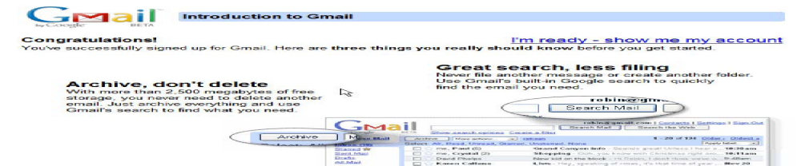
CHECKING YOUR MAIL
Inbox: displays all messages and alerts you of unread messages

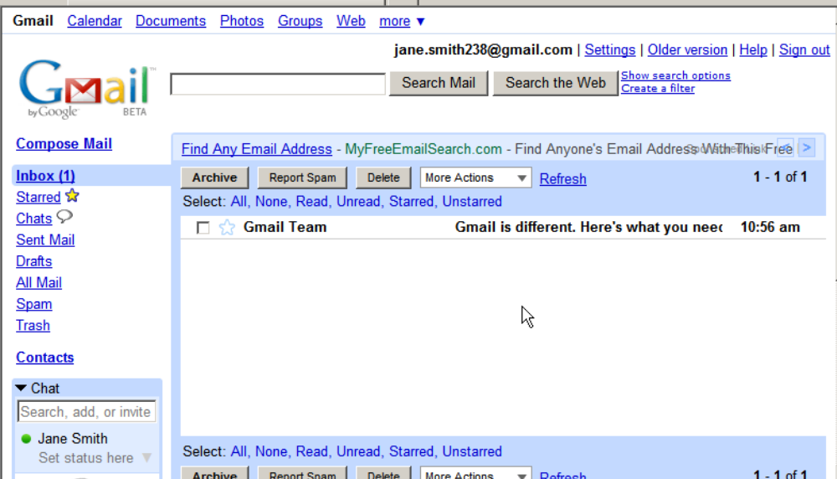
Sender
Message: Click on the message to read the full text.

Viruses are often transmitted through email messages, specifically by opening attachments!
If you are concerned about viruses, don’t open attachments from unknown senders and/ or purchase a virus-checking program to protect your personal computer.

COMPOSE AND SEND A MESSAGE

Now that you have an email account you can create and send messages to other email users. In order to send another user a message, you will need their entire email address.

- Click on the Compose Mail link located on the upper left-hand side of the screen.
- Click in the To: box and type the full email address.
- For this exercise, use calvin@literacyservices.org
- Click in the Subject: box and enter the subject of your message (e.g. “Email Tutorial”)
- Click in the composition box and type your message.
- When you are finished typing your message, click the Check Spelling button to correct any mistakes.
- If a word is misspelled, it becomes highlighted. Click on the highlighted word to see a list of possible correct spellings. When you have selected the correct spelling, click on the word you’ve chosen from the list.
- When you have finished composing your message and correcting spelling mistakes, click the Send button.
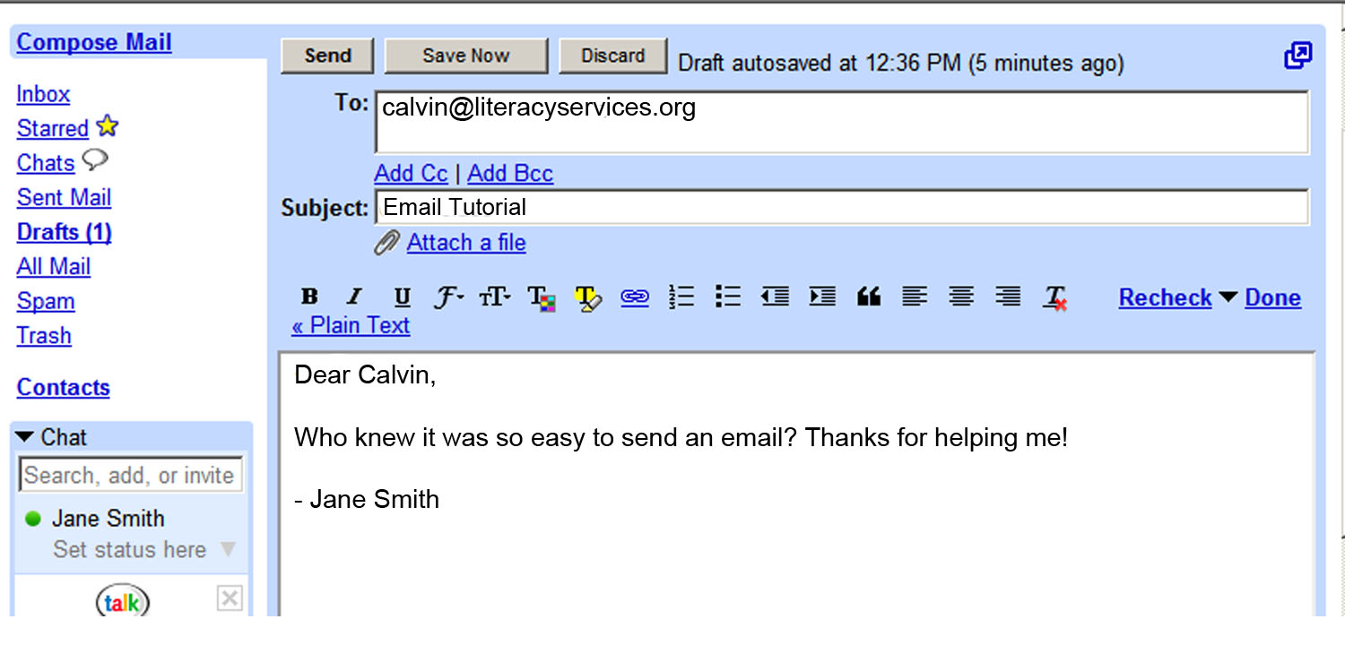
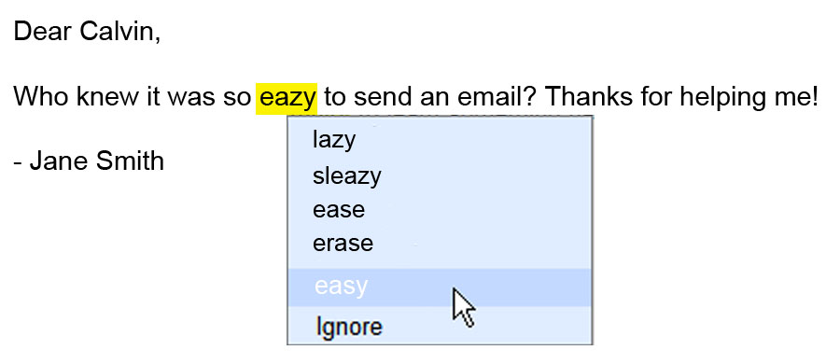
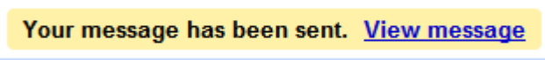
Cc: Carbon Copy. A copy of the email will be sent to the addresses put under carbon copy, and the address will show up to the rest of the recipients.
Bcc: Blind Carbon Copy. Addresses placed under blind carbon copy will receive a copy of the email, but the other recipients will not know that a copy was send to those addresses.

SIGN OUT AND SIGN IN

It is very important that you sign out if you are accessing your email account on a public computer! Otherwise the next person using the computer will be able to view your inbox, read your messages, and possibly send messages using your email address.

Sign Out

- Click on the sign out link on the top left-hand side of the screen.
- Close out of Internet Explorer by clicking on the X on the title bar in the upper right-hand corner of the screen.
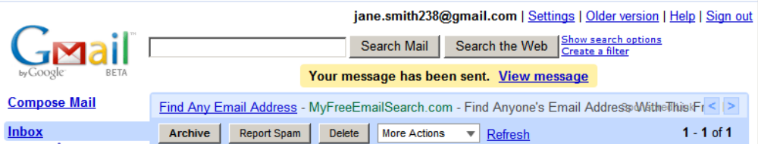

Sign In

- Open Internet Explorer and go to the Google website.
- After the site loads, click on the Gmail link.
- Click in the Username box and type your username.
- Press the Tab key or click in the password box.
- Type your password. (Remember, it will display as dots for security reasons.)
- Remember to uncheck “Remember me on this computer” if you are using a public computer!
- Click the Sign In button or press the Enter key and your account will open.
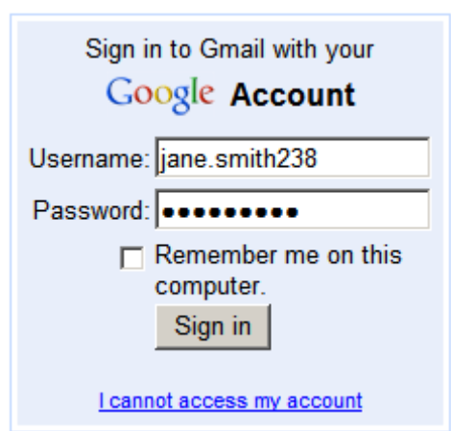
Free Email Providers and Other Links
Users with Internet access are able to register for a free email account giving them the ability to send and receive electronic messages. This service allows users to read and respond to messages from any computer that has an internet connection anywhere in the world. You can sign up for a free email account so you can begin to communicate with friends and family.

Free Email Providers:

http://mail.yahoo.com
http://gmail.com
http://mail.lycos.com
http://www.hotmail.com
http://mail.com
http://www.aolmail.com

Email Info

Free Email Address Directory
http://www.emailaddresses.com

Email Address Verification
http://mailtester.com

Free Email Providers Guide
http://www.fepg.net

All About Email
http://email.about.com

